Filtering and Sorting

Note: Create the following dummy table in MySQL Workbench using CREATE FUNCTION-
Sample Table: Employees

EmpID | EmpName | Department | City | Salary | HireDate
101 | Rahul Mehta | Sales | Delhi | 55,000 | 2020-04-12
102 | Priya Sharma | HR | Mumbai | 62,000 | 2019-09-25
103 | Aman Singh | IT | Bengaluru | 72,000 | 2021-03-10
104 | Neha Patel | Sales | Delhi | 48,000 | 2022-01-14
105 | Karan Joshi | Marketing | Pune | 45,000 | 2018-07-22
106 | Divya Nair | IT | Chennai | 81,000 | 2019-12-11
107 | Raj Kumar | HR | Delhi | 60,000 | 2020-05-28
108 | Simran Kaur | Finance | Mumbai | 58,000 | 2021-08-03
109 | Arjun Reddy | IT | Hyderabad | 70,000 | 2022-02-18
110 | Anjali Das | Sales | Kolkata | 51,000 | 2023-01-15

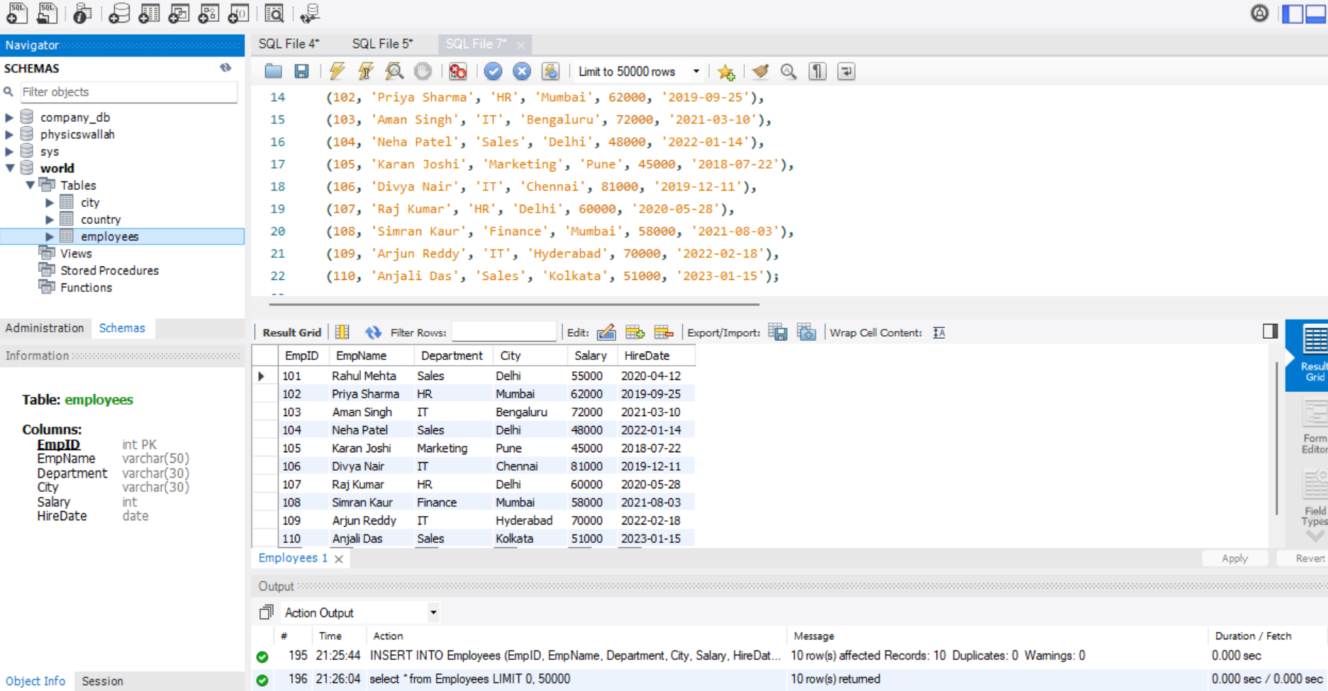

- Show employees working in either the ‘IT’ or ‘HR’ departments.
- select *
from Employees
where department IN ('IT' , 'HR');

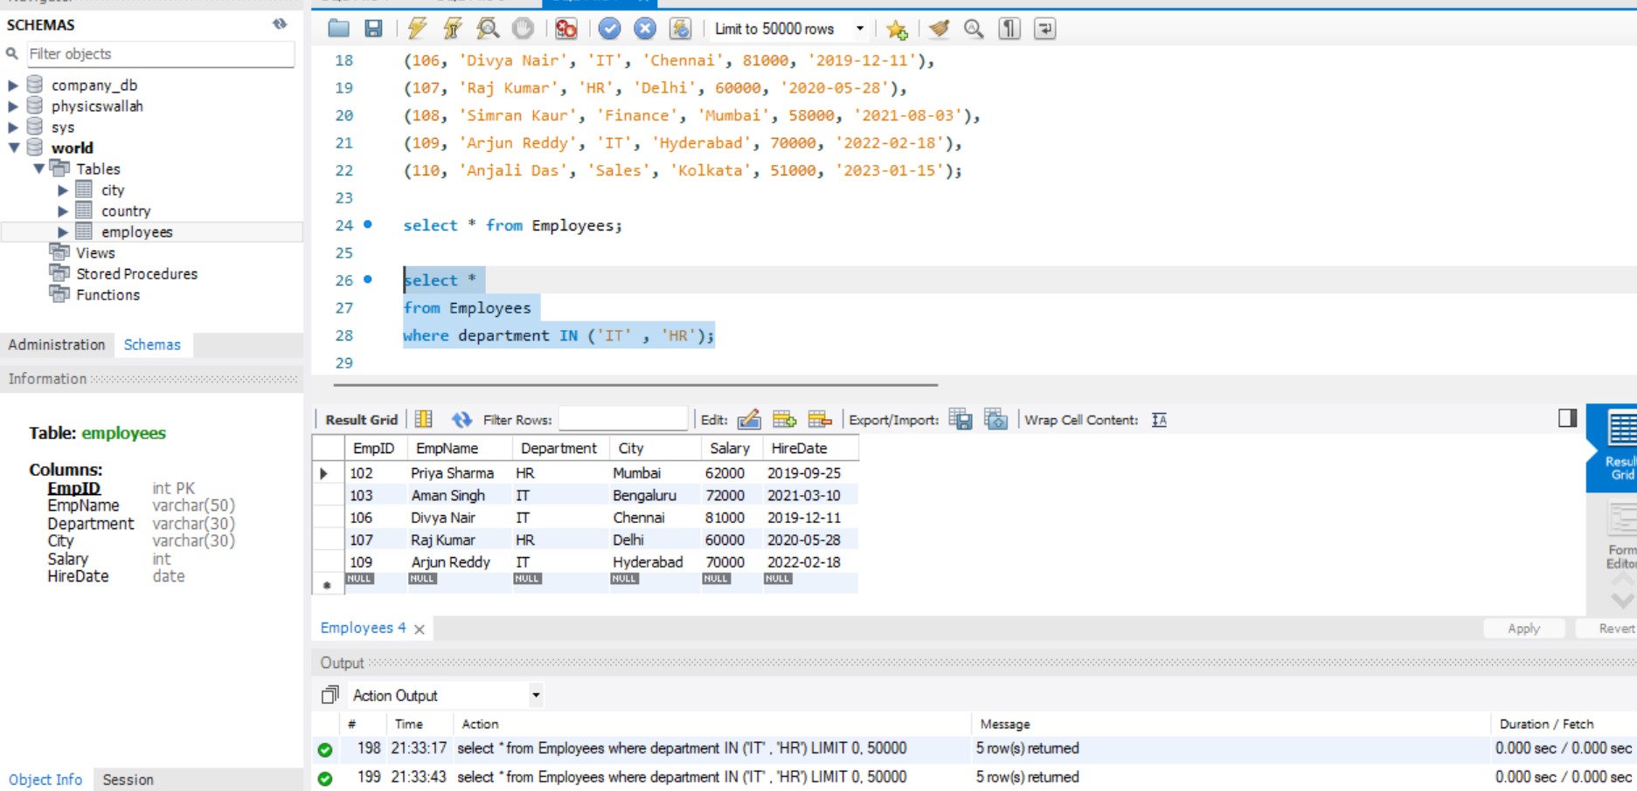

- Retrieve employees whose department is in ‘Sales’, ‘IT’, or ‘Finance’.
- select *
from Employees
where department IN ('Sales' , 'IT' , 'Finance');

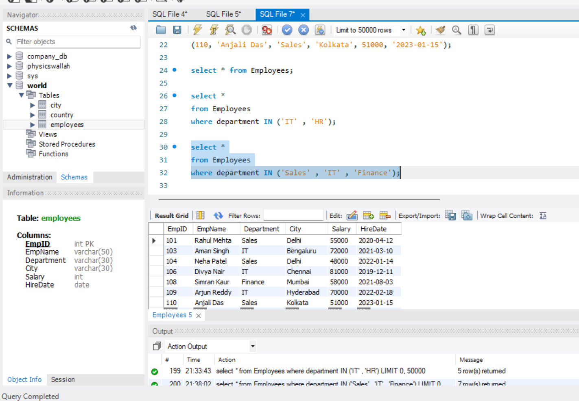
- Display employees whose salary is between ₹50,000 and ₹70,000
- select *
from employees
where salary between 50000 AND 70000;

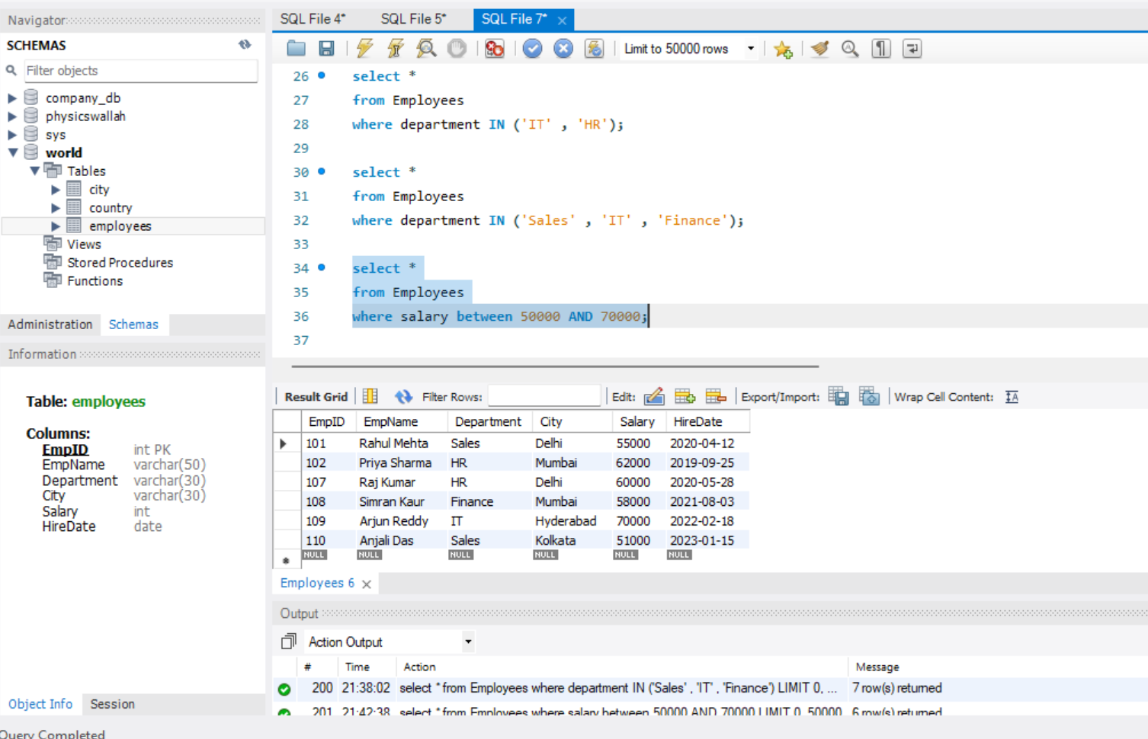

- List employees whose names start with the letter ‘A’.
- select *
from employees
where EmpName LIKE ‘A%’;

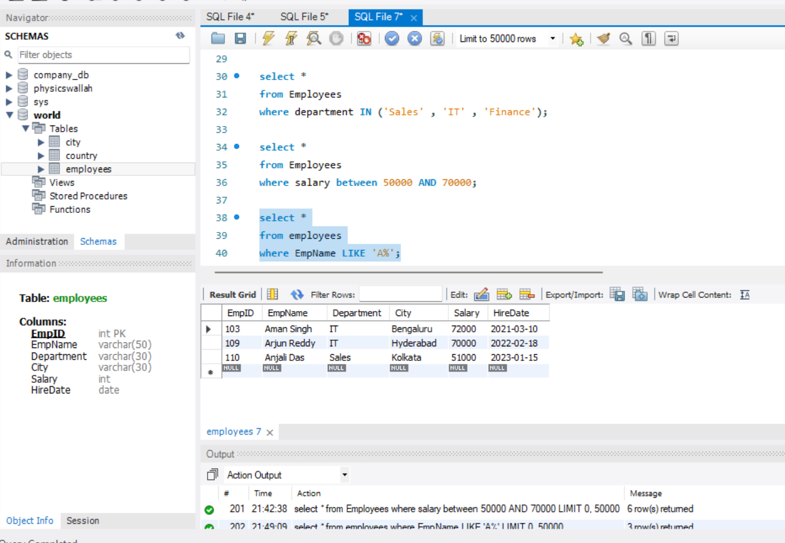
- Find employees whose names contain the substring ‘an’.
- select *
from employees
where EmpName LIKE '%an%';

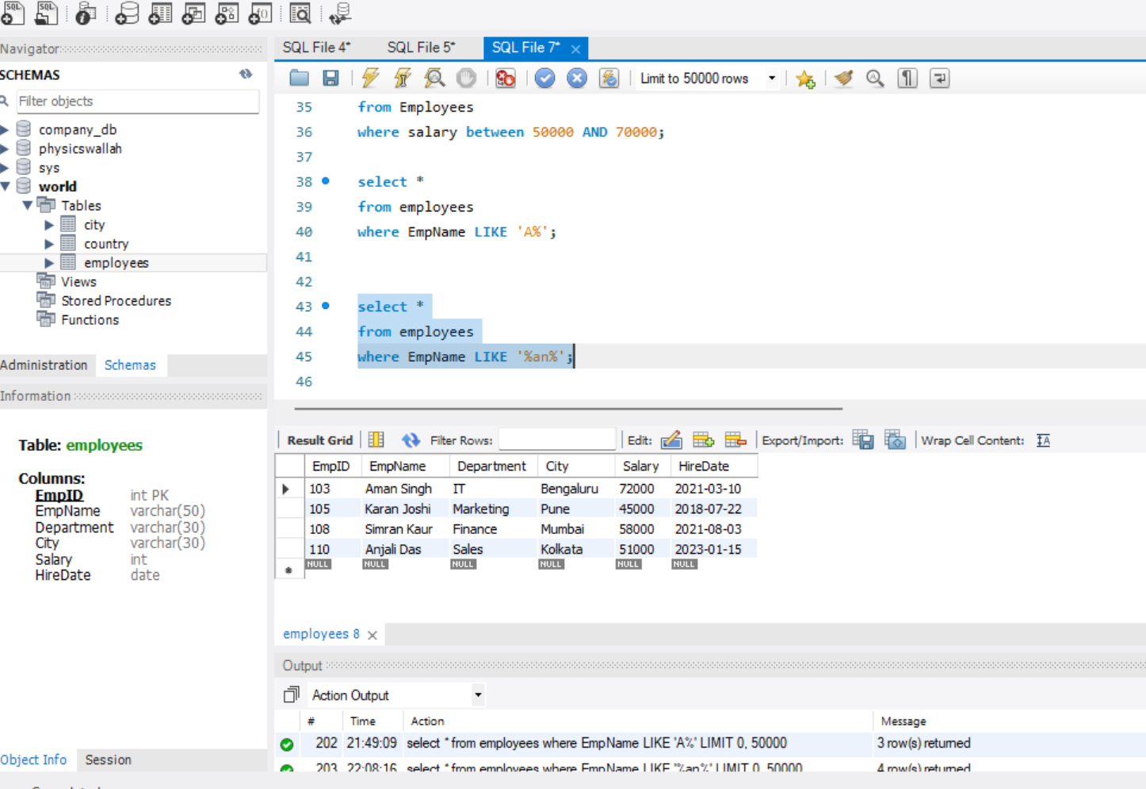

- Show employees who are from ‘Delhi’ or ‘Mumbai’ and earn more than ₹55,000.
- select *
from Employees
where City IN ('Delhi', 'Mumbai')
and Salary > 55000;
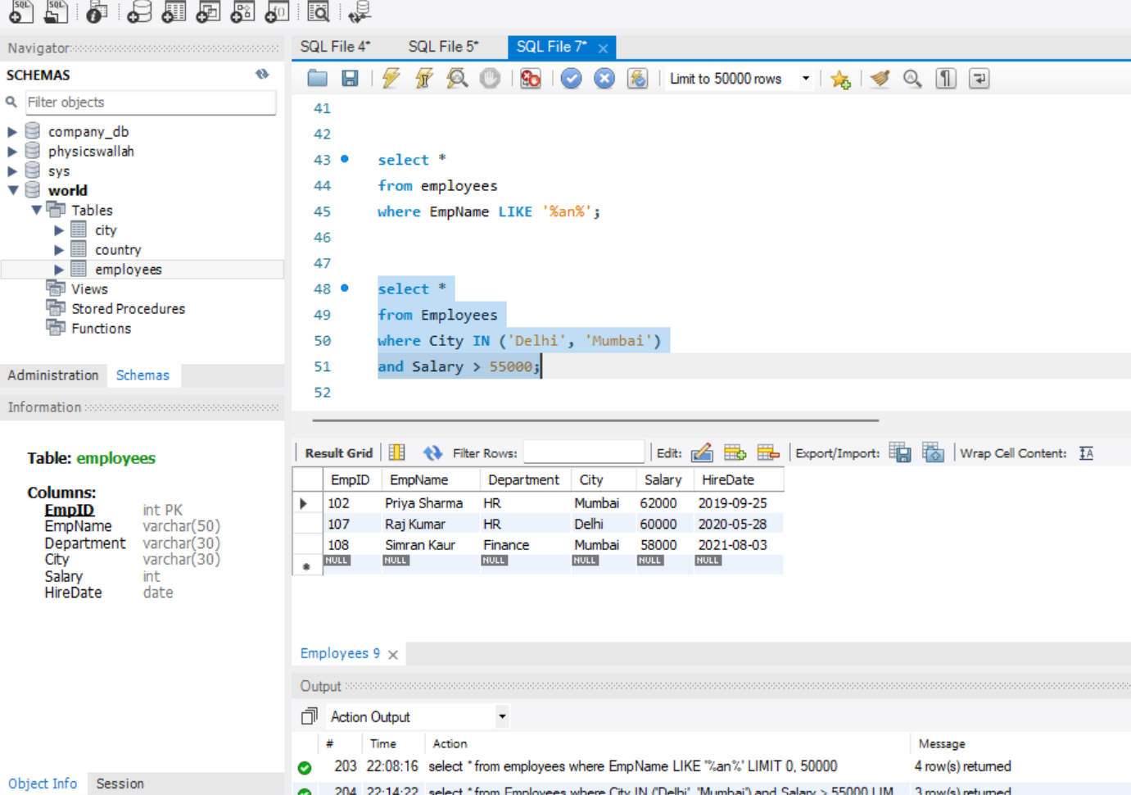

- Display all employees except those from the ‘HR’ department.
- select *
from Employees
where Department NOT IN ('HR');

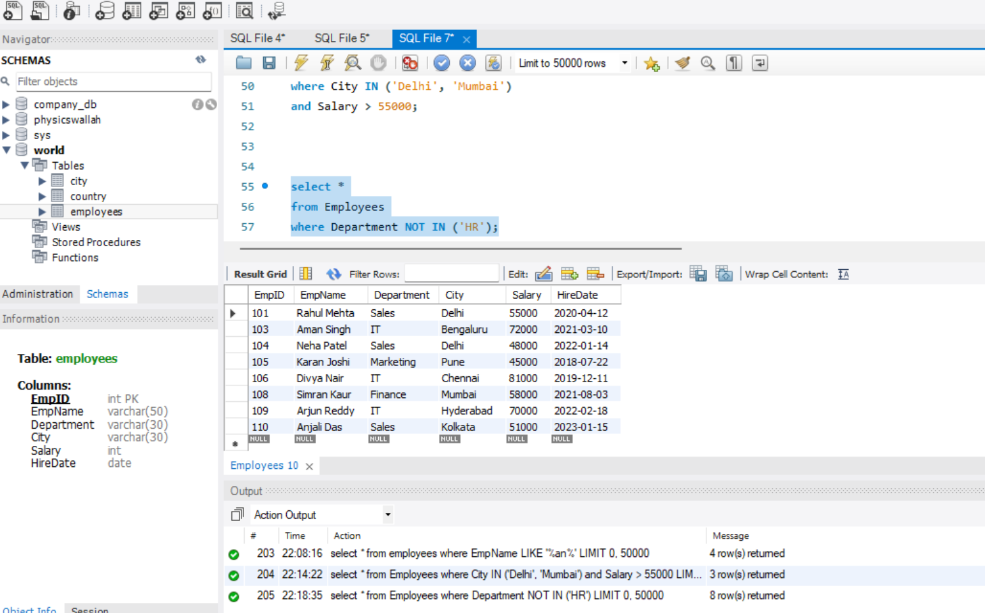

- Get all employees hired between 2019 and 2022, ordered by HireDate (oldest first)
- select *
from Employees
where HireDate BETWEEN '2019-01-01' AND '2022-12-31'
ORDER BY HireDate ASC;

